14.52: Following the hint,

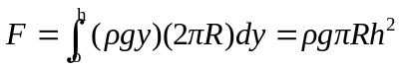
where R and h are the radius and height of the tank (the fact that 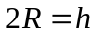is more or less coincidental). Using the given numerical values gives